Power Plan
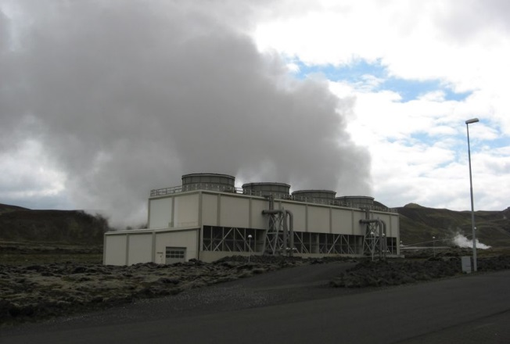
https://education.nationalgeographic.org/resource/power-plan/
Even though it’s a small country, Iceland is rich in natural resources. The island nation, which is about the size of the state of Kentucky, is located in the middle of the north Atlantic Ocean, between Greenland and Scandinavia. Cloud-colored glaciers cover mountain peaks, and waterfalls dangle like tinsel down cliff faces. Across certain areas of Iceland, geysers smoke like battlefields before erupting from the Earth in fire-hose-like blasts of hot water.
Tucked under a volcanic region known as Hengill, surrounded by chunks of dark volcanic rock, the Nesjavellir Power Plant is a fine example of how Iceland harnesses its abundant natural resources for its citizens’ needs. Inside the white complex’s lobby, Nesjavellir Power Plant public relations guide Valgar∂ur Lyngdall Jónsson explains how the facility produces both hot water and energy from the area’s surroundings with minimal impact on the environment.
Dressed in a light-blue collared shirt and black pants, Jónsson jabs a thumb towards the mountain above the power plant and says that it is an active volcano that last erupted 2,000 years ago. Currently, precipitation that falls on the nearby highlands seeps into the ground and becomes heated by hot bedrock. Bedrock is the solid rock beneath the Earth’s soil and sand. This bedrock has been warmed by its proximity to the volcano’s magma.
Volcanic activity occurs in Iceland because the nation is situated on the Mid-Atlantic ridge, a boundary region where the North American tectonic plate and the Eurasian plate are pulling apart. “We are basically standing on the rift itself,” Jónsson says. “We are standing on thin crust, so to speak.”
Jónsson describes Iceland’s history of using the naturally warmed water beneath the island’s crust to heat buildings on the surface. This heating process is known as geothermal heating. Reykjavík, Iceland’s capital and largest city, began to use hot water from under the Earth’s surface to heat a local school as far back as 1930, when Reykjavík District Heating was formed.
After geothermal energy was discovered to be a feasible way to warm Iceland’s structures, drilling began in areas outside of Reykjavík. Engineers drilled in an attempt to uncover regions with supplies of geothermal water. In 1990, Reykjavík Energy, a utility company, opened Nesjavellir Power Plant in one of Iceland’s best geothermal areas. Today, there are six geothermal power plants in Iceland.
In addition, geothermal power plants in Iceland have generated an unexpected by-product from their energy creation: tourism. The runoff water from another geothermal power plant, Svartsengi, has become the most popular tourist destination in Iceland: the Blue Lagoon. The milky blue pool of mineral-rich hot water has become a spa. The Blue Lagoon attracted more than 408,000 tourists (more people than the entire population of Iceland) in 2008.
Questions
- How does Iceland use its geothermal energy?
- Why is volcanic activity typical for Iceland?
- What attracts tourists to geothermal power plants?
- Do you believe that green energy completely replaces fossil fuels in the future?

Vocabulary

- fire-hose – брандспойт, пожарный шланг
- blast – струя
- to harness – использовать,
- proximity – близость, соседство
- rift – трещина, щель
- feasible – осуществимый
- drilling – бурение
- by-product – побочный продукт

Vocabulary

- fire-hose – брандспойт, пожарный шланг
- blast – струя
- to harness – использовать,
- proximity – близость, соседство
- rift – трещина, щель
- feasible – осуществимый
- drilling – бурение
- by-product – побочный продукт

Vocabulary

- fire-hose – брандспойт, пожарный шланг
- blast – струя
- to harness – использовать,
- proximity – близость, соседство
- rift – трещина, щель
- feasible – осуществимый
- drilling – бурение
- by-product – побочный продукт

