Do Changes in Our Climate Mean More Hurricanes?

https://education.nationalgeographic.org/resource/do-changes-our-climate-mean-more-hurricanes/
In recent years, the occurrence and severity of hurricanes both appear to have drastically increased. Scientists have since begun to make connections between climate change and the proliferation of hurricanes.
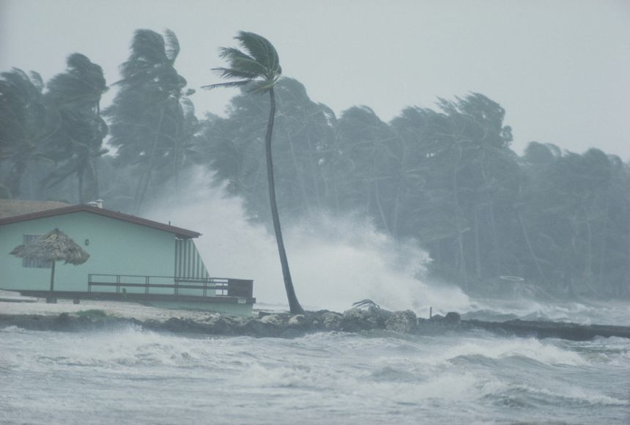
The 2005 hurricane season was unlike any other hurricane season before it. There were fifteen named hurricanes — a new record. Four of these hurricanes were classified as Category 5 hurricanes on the Saffir-Simpson scale. A Category 5 hurricane—the most severe—has wind gusts measuring over 251 kilometers per hour (156 miles per hour) causing devastating damage. Hurricane Katrina (August 23–31, 2005), a Category 3 storm, changed New Orleans, Louisiana, forever, killing over 1,800 people and becoming the costliest hurricane in United State history, causing 162 billion dollars in damages. Just a couple of months later, Hurricane Wilma (October 15–25, 2005) was the strongest hurricane ever recorded with sustained winds of 280 kilometers per hour (175 miles per hour). That same year, peer-reviewed scientific journals published two scientific papers that claimed that there was evidence linking increases in sea-surface temperatures around the world to the number, strength, and destructive ability of hurricanes over the last thirty years.

A hurricane is a tropical storm formed in the Atlantic Ocean, Caribbean Sea, Gulf of Mexico, or Pacific Ocean. To form, hurricanes need warm temperatures; ocean water above 26.5 degrees Celsius (80 degrees Fahrenheit) is considered ideal. Warm ocean waters provide fuel for the tropical storm. Since warm ocean waters are essential to form and maintain a hurricane, scientists wondered if there was a connection between warmer ocean temperatures and an increase in hurricane frequency and strength. Scientists have been examining the effect of climate change on sea-surface temperatures around the globe, using records from as far back as 1880. The data shows a significant surge in global sea-surface temperatures. Researchers suspected that climate change was playing a part in these warmer waters but they needed to find proof.
Ethan Gutmann, a project scientist at the National Center for Atmospheric Research, found a way to show how climate change would affect hurricanes. Gutmann ran a computerized simulation of twenty-two named hurricanes that occurred between 2001 to 2013. In the simulation, he changed the temperature, humidity, wind speed, and direction to mimic the conditions expected in the future as a result of climate change. How did the hurricanes respond to climate change? The hurricanes all had more rain and, on average, stronger wind speeds, but each hurricane reacted differently to climate change.
Meteorologists and atmospheric scientists continue to study possible links between climate change and the frequency and intensity of hurricanes.
Questions
- What made the 2005 hurricane season unusual?
- Which environmental conditions are favorable for hurricane formation?
- Have the scientists proved the influence of climate change on hurricane frequency and intensity?
- Will it be possible for people to take hurricanes under control in the future?
Explanatory notes
- proliferation – распространение
- sustained wind – стабильный ветер
- costly – зд. разрушительный
- evidence – доказательство
- to maintain – поддерживать
- surge – всплеск, резкий подъем
- mimic – имитировать

Explanatory notes
- proliferation – распространение
- sustained wind – стабильный ветер
- costly – зд. разрушительный
- evidence – доказательство
- to maintain – поддерживать
- surge – всплеск, резкий подъем
- mimic – имитировать

Explanatory notes
- proliferation – распространение
- sustained wind – стабильный ветер
- costly – зд. разрушительный
- evidence – доказательство
- to maintain – поддерживать
- surge – всплеск, резкий подъем
- mimic – имитировать

Explanatory notes
- proliferation – распространение
- sustained wind – стабильный ветер
- costly – зд. разрушительный
- evidence – доказательство
- to maintain – поддерживать
- surge – всплеск, резкий подъем
- mimic – имитировать

