North Pole Research
https://education.nationalgeographic.org/resource/north-pole/
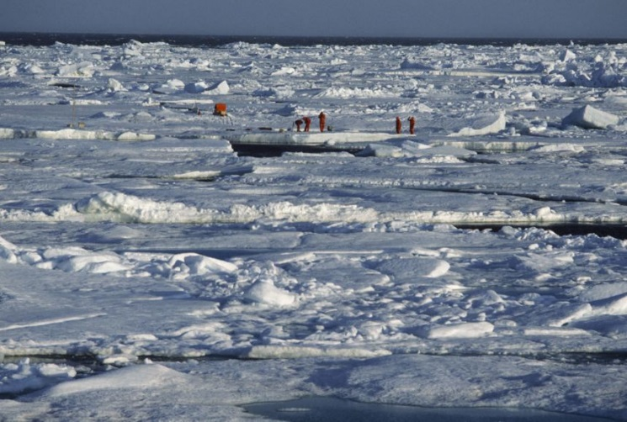
The North Pole is the northernmost point on Earth. From the North Pole, all directions are south. Its latitude is 90 degrees north, and all lines of longitude meet there (as well as at the South Pole, on the opposite end of Earth). Polaris, the current North Star, sits almost motionless in the sky above the pole, making it an excellent fixed point to use in celestial navigation in the Northern Hemisphere.
The North Pole sits in the middle of the Arctic Ocean, on water that is almost always covered with ice. The ice is about two to three meters (six to 10 feet) thick. The depth of the ocean at the North Pole is more than 4,000 meters (13,123 feet). The North Pole is much warmer than the South Pole. This is because sits at a lower elevation (sea level) and is located in the middle of an ocean, which is warmer than the ice-covered continent of Antarctica. But it's not exactly beach weather. In the summer, the warmest time of year, the temperature is right at the freezing point: 0 degrees Celsius (32 degrees Fahrenheit.)
No one actually lives at the North Pole. Inuit people, who live in the nearby Arctic regions of Canada, Greenland, and Russia, have never made homes at the North Pole. The ice is constantly moving, making it nearly impossible to establish a permanent community.
Since the North Pole sits on drifting ice, it's difficult and expensive for scientists and explorers to study. The most consistent research of the North Pole has come from manned drifting research stations. Russia sends out a drifting station almost every year, all named "NP" (for North Pole). Drifting stations monitor the ice pack, temperature, sea depth, currents, weather conditions, and marine biology of the North Pole.
North Pole drifting stations are responsible for many discoveries about the ecosystem at the North Pole. In 1948, for example, bathymetry studies revealed the massive Lomonosov Ridge. The Lomonosov Ridge is an underwater mountain chain stretching across the North Pole, from the Siberian region of Russia all the way to Ellesmere Island, Canada.
Drifting stations have recorded the development of cyclones in the Arctic, as well Arctic shrinkage. Arctic shrinkage is climate change in the Arctic, including warming temperatures, the melting of the Greenland ice sheet (resulting in more freshwater in the marine environment), and a loss of sea ice.
Questions
- Why is the North Pole much warmer than the South Pole?
- Have any people ever lived at the North Pole?
- How do the researchers study the North Pole?
- Is it reasonable to explore such a hard-to reach unlivable region?

Vocabulary
- latitude ['lætɪtju:d] – широта
- longitude ['lɔnʤɪtju:d] – долгота
- celestial navigation ['prevələnt] – мореходная астрономия
- Inuit ['ɪnjʊɪt] people – эскимосы
- consistent – систематический, основательный
- manned – обслуживаемый людьми
- ice pack – дрейфующий лед
- bathymetry [bæ'θɪmɪtrɪ] – батиметрия, измерение водных глубин
- shrinkage – сокращение, уменьшение размеров
- unlivable – непригодный для жизни

Vocabulary
- latitude ['lætɪtju:d] – широта
- longitude ['lɔnʤɪtju:d] – долгота
- celestial navigation ['prevələnt] – мореходная астрономия
- Inuit ['ɪnjʊɪt] people – эскимосы
- consistent – систематический, основательный
- manned – обслуживаемый людьми
- ice pack – дрейфующий лед
- bathymetry [bæ'θɪmɪtrɪ] – батиметрия, измерение водных глубин
- shrinkage – сокращение, уменьшение размеров
- unlivable – непригодный для жизни

Vocabulary
- latitude ['lætɪtju:d] – широта
- longitude ['lɔnʤɪtju:d] – долгота
- celestial navigation ['prevələnt] – мореходная астрономия
- Inuit ['ɪnjʊɪt] people – эскимосы
- consistent – систематический, основательный
- manned – обслуживаемый людьми
- ice pack – дрейфующий лед
- bathymetry [bæ'θɪmɪtrɪ] – батиметрия, измерение водных глубин
- shrinkage – сокращение, уменьшение размеров
- unlivable – непригодный для жизни

