Living in the Mount Everest Watershed
https://education.nationalgeographic.org/resource/living-mount-everest-watershed/

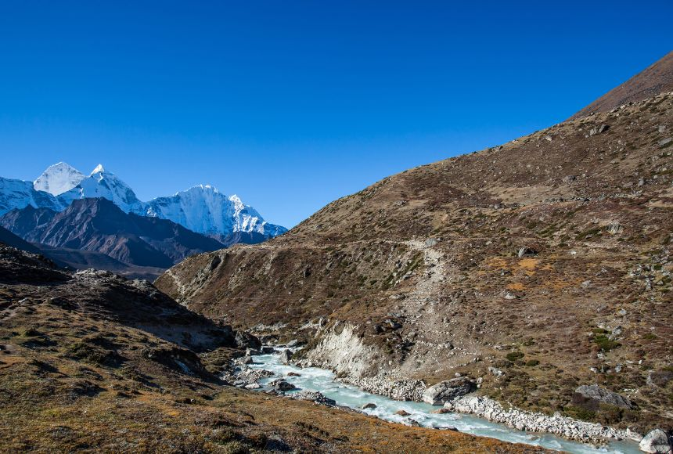
Water is a vital component of life, and over one billion people rely on the freshwater provided by the Mount Everest watershed. It is essential to protect the health of freshwater sources like this one and ensure that everyone has access to clean water.
Mount Everest is the highest point in the world, with a summit of 8,849 meters (29,032 feet) above sea level. It is part of the Himalaya, which spans 2,400 kilometers (1,500 miles) across the countries of India, China, Nepal, India, Pakistan, and Afghanistan.
Mountains like these are known as the water towers of the world, because they provide half of the world’s population with freshwater. Ten major rivers originate in the Himalaya and supply freshwater to 1.3 billion people living in its watershed.
It is easy to take water for granted. In developed countries, a person can turn on a faucet and instantly have clean running water. It is used for a variety of everyday activities, such as brushing teeth, taking a shower, flushing the toilet, preparing food, washing clothes, watering gardens, and more. To some, clean water may seem ordinary and ever-present—but to others it is one of the most rare and precious resources on the planet. On average, rural women in Africa and Asia walk 5 kilometers (3 miles) or more each day to collect water for their household. It is estimated that, across the world, women and girls collectively spend 200 million hours obtaining water every day.
The global population is growing exponentially, and demand for water is increasing. The Everest watershed is particularly stressed by this growing demand. People living in this region face a future with reduced Himalaya glaciers, which could dramatically change the behavior of rivers like the Sapt Kosi and Ganges. Further, the growing Indian population is a strain on the Ganges, demanding more clean water than it can provide, which increases the burden on women and girls who have to travel farther afield to find a safe supply. Access to water is a basic human right, and the United Nations Sustainable Development Goal (SDG) for clean water and sanitation calls for “universal and equitable access to safe and affordable drinking water” by 2030. According to the 2019 Hindu Kush Himalaya Assessment, to reach this goal in the Everest watershed, national governments, local governments, and local organizations need to work together to strengthen water management both in mountain and downstream communities.

Questions

- Why is Mount Everest known as one of the water towers of the world?
- Do all people have universal and equitable access to clean water?
- Why is the world demand for drinking water increasing?
- Whose responsibility is to protect the health of freshwater sources?

Vocabulary
- watershed – водосборный бассейн
- to take for granted – принимать как само собой разумеещееся
- faucet ['fɔ:sɪt] – водопроводный кран
- rural – сельский
- exponentially – многократно, в геометрической прогрессии
- demand – потребность
- strain – нагрузка
- Sustainable Development Goal – цель устойчивого развития
- equitable ['ekwɪtəb(ə)l] – равноправный

Vocabulary
- watershed – водосборный бассейн
- to take for granted – принимать как само собой разумеещееся
- faucet ['fɔ:sɪt] – водопроводный кран
- rural – сельский
- exponentially – многократно, в геометрической прогрессии
- demand – потребность
- strain – нагрузка
- Sustainable Development Goal – цель устойчивого развития
- equitable ['ekwɪtəb(ə)l] – равноправный

Vocabulary
- watershed – водосборный бассейн
- to take for granted – принимать как само собой разумеещееся
- faucet ['fɔ:sɪt] – водопроводный кран
- rural – сельский
- exponentially – многократно, в геометрической прогрессии
- demand – потребность
- strain – нагрузка
- Sustainable Development Goal – цель устойчивого развития
- equitable ['ekwɪtəb(ə)l] – равноправный

