Geology of the Deep
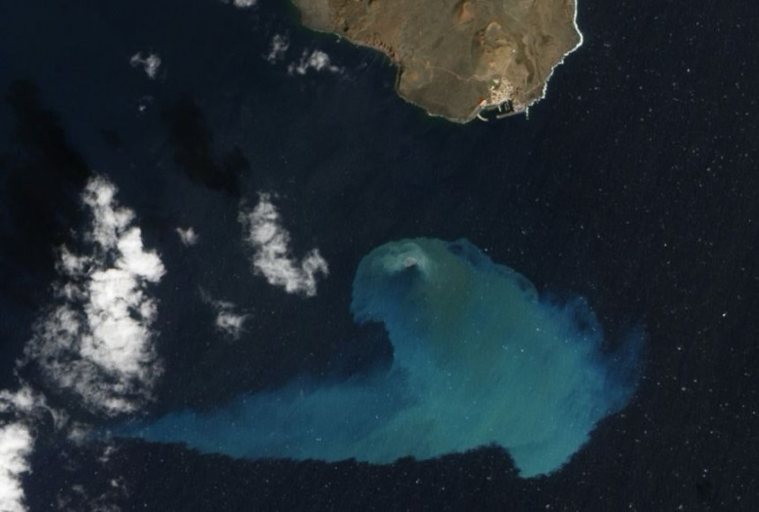
https://education.nationalgeographic.org/resource/geology-deep/
From Hawaii to Indonesia to Iceland, hundreds of islands across the globe have been formed by submarine volcanoes.
Because they erupt into water instead of air, submarine volcanoes behave quite differently than terrestrial volcanoes. For instance, it’s uncommon for submarine volcanoes to have explosive eruptions. Most submarine eruptions do not disturb the ocean surface.
Charles Mandeville is the program coordinator for the Volcano Hazards Program of the United States Geological Survey (USGS). He and his colleagues are responsible for monitoring all 169 active volcanoes—all terrestrial—in the United States. Prior to joining the USGS, Mandeville focused his research on submarine volcanology, becoming an expert on the famous 1883 eruption of the island of Krakatoa in Indonesia. According to Mandeville, there are two main factors that contribute to submarine volcanoes eventually forming islands: the supply of magma and tectonic activity.
“The first thing you need is a supply of magma,” he says. “Typically, in the origin of most oceanic island volcanoes or submarine volcanoes, you need to melt the Earth’s mantle.” Most volcanic islands originate from passive lava flows on the seafloor. These passive flows harden into rock and build up the height of the underwater mountain over millions of years. Eventually, some volcanoes reach heights above the seafloor where lower pressure allows for explosive eruptions. Submarine volcanoes that do not reach sea level are called seamounts.
In addition to magma supply, plate tectonics play a large part in determining which submarine volcanoes will eventually form islands. Tectonic activity can sometimes “take the island volcano away from the source of magma that originates in the mantle, because the tectonic plate that the volcano is growing upon is moving,” says Mandeville.
One of the world’s most recently formed volcanic islands is part of the island nation of Tonga, in the South Pacific Ocean. Tonga is an archipelago of 170 volcanic islands. The new landmass formed in March 2009 as an explosive eruption sent steam, volcanic gases, and volcanic ash roughly 800 meters (2,625 feet) into the sky, covering the uninhabited island of Hunga Ha’apai—63 kilometers (39 miles) away—in black, volcanic ash. Days later, a second, smaller eruption from a vent between Hunga Ha’apai and the new landmass combined with rock and debris from the initial eruption to fill the space between the two. The result was a single landmass nearly double the original size of Hunga Ha’apai. Though Hunga Ha’apai previously had rich plant and animal life, the ash from the eruption devastated its ecosystem. It’s unclear whether the new island will evolve to be able support larger life forms.
In the years since the 2009 eruption, the young island has maintained itself above sea level and experienced significant growth after a series of eruptions in late 2014 and early 2015 added to its landmass. It is still attached to Hunga Ha’apai and is in the very early stages of developing an ecosystem.
Questions

- How do submarine volcanoes differ from terrestrial ones?
- Do all submarine volcanoes eventually form islands?
- When and where was one the youngest volcanic islands formed?
- Why is it necessary to study submarine volcanology?

Vocabulary

- terrestrial – наземный
- explosive eruption – бурное извержение со взрывами
- eventually – со временем, в конечном итоге
- mantle – мантия
- plate tectonics – тектоника плит
- ash – пепел
- vent – жерло вулкана
- debris [ˈde(ɪ)bri:] – обломки пород
- to devastate – разрушать

Vocabulary

- terrestrial – наземный
- explosive eruption – бурное извержение со взрывами
- eventually – со временем, в конечном итоге
- mantle – мантия
- plate tectonics – тектоника плит
- ash – пепел
- vent – жерло вулкана
- debris [ˈde(ɪ)bri:] – обломки пород
- to devastate – разрушать

Vocabulary

- terrestrial – наземный
- explosive eruption – бурное извержение со взрывами
- eventually – со временем, в конечном итоге
- mantle – мантия
- plate tectonics – тектоника плит
- ash – пепел
- vent – жерло вулкана
- debris [ˈde(ɪ)bri:] – обломки пород
- to devastate – разрушать

