IRAQ YET AGAIN HIT BY DUST STORM
https://www.theguardian.com/world/2022/may/02/iraq-engulfed-by-dust-storm

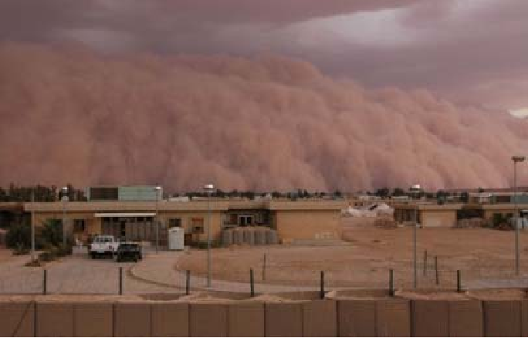
A dust storm engulfed parts of Iraq for multiple days in early April 2022, turning skies orange, reducing visibility, and degrading air quality.
Dust storms in Iraq are most common in the summer, provoked by the shamal—strong winds that blow from the northwest. But they can occur in other seasons, too. Western Iraq, for example, sees more shamal-driven dust storms in spring. According to a report from The World Bank, northern Iraq—between the Tigris and Euphrates rivers and along the border of Syria—has the highest density of dust sources in the Middle East.
On April 7, most of the dust was drifting over northern Iraq; two days later, the plume extended south past Baghdad. News reports indicate that dozens of people across the country were hospitalized with respiratory problems during the recent outbreak. A thick layer of orange dust settled across streets and vehicles, seeping into people’s homes in the capital Baghdad.
Flights were grounded because of poor visibility at airports serving Baghdad and the Shia holy city of Najaf, with the phenomenon expected to continue into Monday, according to the weather service. “Flights have been interrupted at the airports of Baghdad and Najaf due to the dust storm,” the spokesperson for the civil aviation authority, Jihad al-Diwan, said. Visibility was cited at less than 500 meters, with flights expected to resume once weather improves.Hospitals in Najaf received 63 people suffering from respiratory problems as a result of the storm, a health official said, adding that the majority had left after receiving appropriate treatment. Another 30 hospitalizations were reported in the mostly desert province of Anbar in the west of the country.
Amer al-Jabri, of Iraq’s meteorological office, previously said the weather phenomenon is expected to become increasingly frequent “due to drought, desertification and declining rainfall”. Iraq is particularly vulnerable to climate change, having already witnessed record low rainfall and high temperatures in recent years. Experts have said these factors threaten to bring social and economic disaster in the war-scarred country. In November, the World Bank warned that Iraq could suffer a 20% drop in water resources by 2050 due to climate change. In early April, Issa al-Fayad, an environment ministry official, had warned that Iraq could face “272 days of dust” a year in coming decades, according to the state news agency INA. The ministry said the weather phenomenon could be addressed by “increasing vegetation cover and creating forests that act as windbreaks”.

Questions

- Are dust storms uncommon for Iraq?
- What were the consequences of the last dust storm outbreak?
- What is the experts’ forecast for future concerning the dust storms?
- Is it possible for people to take life-threatening weather phenomena under control?

Vocabulary

- to engulf – поглотить, охватить
- plume – зона, (зд.) облако
- to seep – просачиваться
- to interrupt – приостановить
- to resume – возобновить
- desertification – опустынивание
- vulnerable – подверженный

Vocabulary

- to engulf – поглотить, охватить
- plume – зона, (зд.) облако
- to seep – просачиваться
- to interrupt – приостановить
- to resume – возобновить
- desertification – опустынивание
- vulnerable – подверженный

Vocabulary

- to engulf – поглотить, охватить
- plume – зона, (зд.) облако
- to seep – просачиваться
- to interrupt – приостановить
- to resume – возобновить
- desertification – опустынивание
- vulnerable - подверженный

